In [7]:
x = 2
lr = 0.01
precision = 0.000001
previous_step_size = 1
max_iter = 10000
iters = 0
gf = lambda x: (x+3) ** 2

In [8]:
1
import matplotlib.pyplot as plt



In [9]:
1
gd = []

In [10]:
1
2
3
4
5
6
7
while precision < previous_step_size and iters < max_iter: prev = x
x = x -lr * gf(prev)
previous_step_size = abs(x - prev) iters += 1
print('Iteration:', iters, 'Value:',x) gd.append(x)
Iteration: 1 Value: 1.75
Iteration: 2 Value: 1.524375
Iteration: 3 Value: 1.31967530859375
Iteration: 4 Value: 1.133079360877005
Iteration: 5 Value: 0.9622559108439301
Iteration: 6 Value: 0.8052611918137536
Iteration: 7 Value: 0.6604610644345152
Iteration: 8 Value: 0.5264713123921045
Iteration: 9 Value: 0.4021113132208596
Iteration: 10 Value: 0.28636769934540596
Iteration: 11 Value: 0.1783655727923978
Iteration: 12 Value: 0.07734549564927831
Iteration: 13 Value: -0.017355057346650715
Iteration: 14 Value: -0.10631676588600673
Iteration: 15 Value: -0.19005079247993095
Iteration: 16 Value: -0.26900893796835756
Iteration: 17 Value: -0.34359205977732477
Iteration: 18 Value: -0.41415709122610556
Iteration: 19 Value: -0.4810229267146679

In [12]:
1
print('Local Minima:', x)
Local Minima: -2.990001240409911

In [15]:
plt.plot(gd)
1
Out[15]:
[<matplotlib.lines.Line2D at 0x206d090a1f0>]
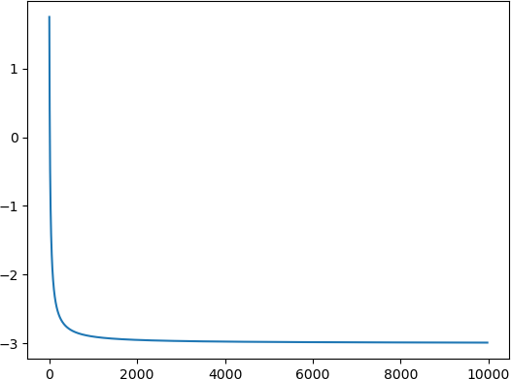

In [ ]:
1

